**Magha Puja the Fourfold Festival of Buddhists:**

Magha Puja is an important festival celebrated by Buddhists. Generally, this festival celebrates on the full moon day of the third month in March. According to the legends of

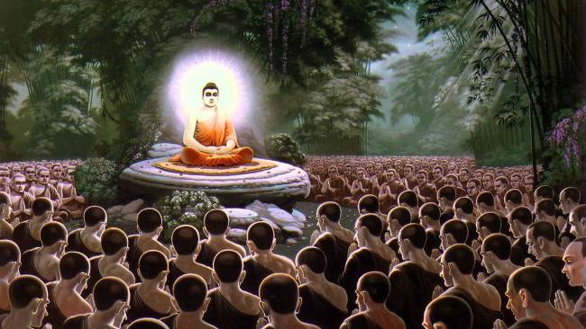

[Gautama Buddha](https://indiathedestiny.com/india-philosophers/buddha-founder-buddhism/), once Lord Buddha stayed in the deer park in Sarnath on the way to Rajagaha city. Then around 1250 arahants along with the important Buddha disciples Sariputta and Moggalana reached the place to worship Buddha. When they visited Gautama Buddha, celebrated Puja to Gauthama Buddha. Then the enlightened Buddha delivered his lecture to the visitors and vanished their dogmas towards their lives. Then the appeased devotees celebrated puja to honour Lord Buddha. This event happened in the early life of Buddha and the first puja was celebrated on ‘Magha’ month so that this puja has been continuing till now in the month of Magha.

**History of Magha Puja:**

This festival is also known as fourfold Sangha day. According to the legendaries, the first Sangha indicates that all the 1250 Buddhists were arahants. The second Sangha says Buddha ordained all the 1250 Buddhists. Thirdly all the Buddhist followers gathered on their own to conduct Puja to honour Lord Buddha even Buddha did not invite them. Lastly, the fourth fold Sangha explains that all the 1250 Buddhist followers gathered on full moon day in the Magha month and celebrated Puja to Buddha. Hence Magha Puja has been celebrating the month of Magha.

**Celebrations of Magha Puja:**

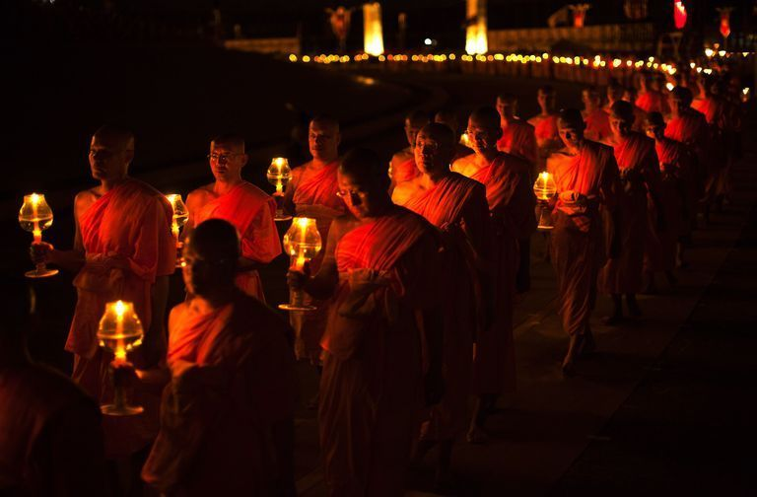

The Buddhists celebrate the Magha Puja with a lot of pomp. It is a very significant festival to the Buddhist community. Especially the festival honours the Sangha and Buddhist community. The Sangh plays an important role in embodies the tradition, culture and the rules of Buddhist life and protects the principles of Dhamma.  
On the day of Magha Puja, the devotees meet jointly and read the teachings of Lord Buddha. Later they discuss the theme of the of Dhammapada. In the middle of the discussion, the senior devotees or monks deliver their speeches about the importance of Dhammapada and Sangh. Everyone wants to lead their lives in the service of Lord Buddha. Later these discussions, the devotees exchange the gifts among them and lighting the oil lamps.